JK01 Kerry series no. 1 [1905]
[described in Kerry's 1908 brochure as 'Assorted Old Caves']

Ph Charles Kerry
Pu Kerry & Co.
Pr In Germany by collotype
F Printed from photographs in four different styles as below.

- Title superimposed upon photograph
[Note: The German word 'serie' appears on many cards]
- No printer's imprint on back JK01A
- Imprinted 'Made in Germany' JK01B
- Title on white marginal strip at base
- black & white JK01C
- coloured JK01D

[Note : some cards have the picture inverted relative to the printing on the back of the card.]

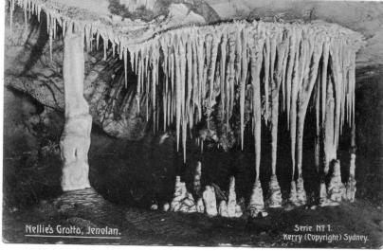 | 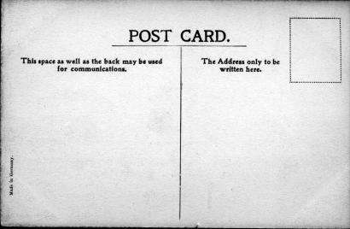
Design of 01A & 4B | Back of 01B with imprint at lower left

JK01A.1 Underground River. R.I. Jenolan. Imperial Cave H
JK01A.2 Nellie's Grotto, Jenolan H (s.n.a. JK0.2) [pm.23 Jan.1907]
JK01A.3 The Caves Hotel, Jenolan H [pm.12 Mar.1907]
Message says '. . . we came in a motor car.'
A further example, pm. 2 Aug.1906, was sent by J.C. Wiburd to Mrs. S. Selby of Devon, England. The message reads : Dear Ada, On this P.C. you will see the Accomodation House, Post Office, Photo Kiosk and our house up on the hill but I will send you a better one when I get it. Bitterly cold and snow on all the hill tops. Dad, Ma and Bell are home from their holidays. Hope you are all well. Love to self Sid and the children. J.W.
It is perhaps also worth noting that we also have a letter pm. 7 Dec.1898 from Syd (who says he will leave the news to Ada) to Wiburd about arrangements for sending him the local paper, so this correspondence is evidently part of a long-standing friendship.
JK01A.4 Grand Arch, West Side, Jenolan H (s.n.a.JK00.7) [pm.15 Oct.1906]
JK01A.5 The Grand Column, River Cave. Jenolan V [pm.4 Jul.1907]
JK01A.6 The Minaret, River Cave, Jenolan V (s.n.a. JK00.14) [pm.6 Apr.1907]
JK01A.8 Gem of the West. R.I. Jenolan V [pm.30 Aug.1906] (Note: retouched to delete pipe that was visible across other images of this view)
JK01A.9 Show Room. R.I. Jenolan V [pm.16 Nov.1905]
JK01A.11 Crystal Palace, R.I. Jenolan V (s.n.a. JK0.1, retouched) [pm.18 Oct.1906]
JK01A.12 Katie's Bower. L.I. Jenolan V (s.n.a. JK0.12) [pm.15 Jan.1907]
JK01A.13 Carlotta Arch. Jenolan V (s.n.a. JK0.15) [pm.5 Feb.1907]
JK01A.15 Grand Arch & Bridge Jenolan V (s.n.a. JK0.13) [pm.12 Mar.1907]

The two images of the Gem of the West, with re-touched version on left.  Note also the design of 01.4C | 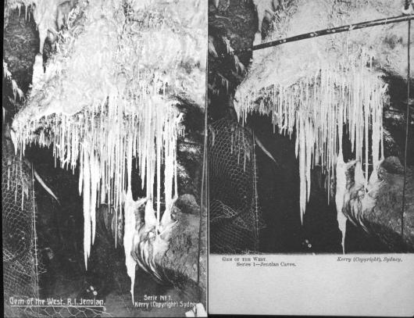

JK01B.1 Underground River. R.I.Jenolan. Imperial Cave H [pm.1908]
JK01B.2 Nellie's Grotto, Jenolan H (s.n.a. JK0.2) [pm.27 Nov.1908]
Sender says 'We were here and have seen the underground river & cave & they throw money in it & it cleaned out once a year and given to charities nearest Jenolan. They are fine caves but nothing as pretty as Naracoorte. These are more extensive and go for miles & in places 2JK80 feet high...'
The underground river today is often cloudy and carries a considerable silt load so that it would not serve as a 'wishing well'.
On another card, ms. 17 Sept.1908, sender says 'We are having a good time stayed at Katoomba Wed. night. Thurs. morning caught paper train to Medlow. caught 9 o'c train (sic) to Jenolan. Glorious drive, marvellous sights, very cold clear weather. 5.00 Friday arrived at Medlow again after delightful drive. Will stay here tonight back to Katoomba tomorrow arrive Sydney early Monday.'
JK01B.3 The Caves Hotel, Jenolan H [pm.1911]
JK01B.4 Grand Arch, West Side. Jenolan H (s.n.a. JK0.7)
JK01B.5 The Grand Column, River Cave. Jenolan V [pm.22 Sep.1908]
JK01B.6 The Minaret, River Cave, Jenolan V (s.n.a. JK00.14) [pm.5 Oct.1909]
Another copy [pm.16 Jan.1909] has been sent from Cooke's Kia-Ora guesthouse, and has the beginning of a letter, which says, '. . . there are about 20 caves and you can visit only one at a time. You have to have a guide and they only take you for a day . . '. (continued on JK031A.11 - see below).
JK01B.6 Gem of the West. R.I.Jenolan V [pm.28 Feb.1908]
[s.n.a. JK0.8 retouched to delete pipe that was visible across earlier image]
JK01B.9 Show Room. R.I. Jenolan V [ms.17 Sep.1908]
JK01B.11 Crystal Palace, R.I. Jenolan V [s.n.a. 2.1, retouched] [pm.7 Nov.1907]
JK01B.12 Katie's Bower. L.I. Jenolan V (s.n.a. 3.12) [pm.13 Nov.1908]
JK01B.13 Carlotta Arch. Jenolan V (s.n.a. 3.15)
JK01B.15 Grand Arch & Bridge Jenolan V (s.n.a. 3.13)

Two images of the Crystal Palace, with the retouched version on the right. | 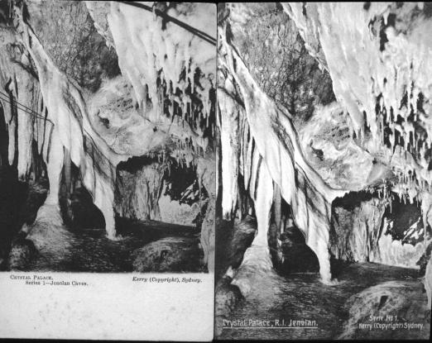

JK01C.1 Underground River H [pm.17 Jan.1906]
JK01C.2 Nellie's Grotto H (s.n.a. JK00.2) [pm.11 Oct.1905]
JK01C.3 Caves Hotel H [pm.19 Jul.1906]
JK01C.4 Grand Arch, West Side H (s.n.a. JK0.7) [pm.13 Jan.1906]
JK01C.5 Grand Column, River Cave V [pm.13 Feb.1906]
JK01C.6 The Minaret V (s.n.a. JK0.14) [pm.26 Dec.1905]
JK01C.7 Gem of the West V (s.n.a. JK0.8 - not retouched) [pm.11 Dec.1905]
We have one example [pm.11 Jan.1907] that appears to have been
mailed home (to Schenectady, N.Y.) by an American Visitor. The
message on the back says, '. . . We are at the caves for some days
seeing the sights. Simply wonderful beyond description & much vaster
than I thought possible. Going thro' a very steep one tomorrow & in a
boat in the bowels of the earth part of the way.' The front also bears a
note saying 'This is only one little gem of the Left Imperial Cave,
impossible for a print to convey any idea of the glistening beauty.
Nothing like this in America !!'
JK01C.9 Showroom V [pm.23 Dec.1905]
JK01C.10 Crystal Palace V (s.n.a. JK00.1, not re-touched) [pm.7 Mar.1906]
JK01C.12 Katie's Bower V (s.n.a. JK0.12) [pm.29 Aug.1905]
JK01C.13 Carlotta Arch V (s.n.a. JK0.15) [pm.30 Mar.1906]
JK01C.14 Grand Arch, East Side V (s.n.a. JK0.13) [pm.10 Nov.1905]

JK01D.2 Nellie's Grotto H (s.n.a. JK00.2)
[This card has been hand-coloured, and this was often done by
retailers rather than by the publisher]
SUMMARY: Jenolan JK1 - Cards known to date.

 |  | A | B | C | D
JK1.1  JK1.2  JK1.3  JK1.4  JK1.5  JK1.6  JK1.7  JK1.8  JK1.9  JK1.10  JK1.11  JK1.12  JK1.13  JK1.14  JK1.15 | Underground River  Nellie’s Grotto  Caves Hotel  Grand Arch, West  Grand Column  The Minaret  Gem of the West  (not retouched)  Gem of the West  (re-touched)  Showroom  Crystal Palace  (not re-touched)  Crystal Palace  (re-touched)  Katie’s Bower  Carlotta Arch  Grand Arch, East  Grand Arch & Bridge | *  *  *  *  *  *  *  *  *  *  *  * | *  *  *  *  *  *  *  *  *  *  *  * | *  *  *  *  *  *  *  *  *  *  *  * | *

JK31. Kerry Series 31 - Jenolan B [1905]
(Described by Kerry in his 1908 brochure as "Assorted New Caves")

Ph Charles Kerry
Pu Kerry & Co.
Pr In Germany by collotype in five styles as below.

- Title superimposed on print JK31A
- No Title on card, but otherwise as JK31A JK31B
- Title on white marginal strip at base of card
- Single line dividing back JK31C
- Double line dividing back JK31D
- Title on back of card in red JK31E

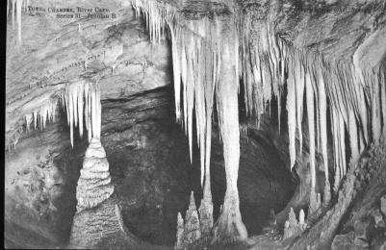 | 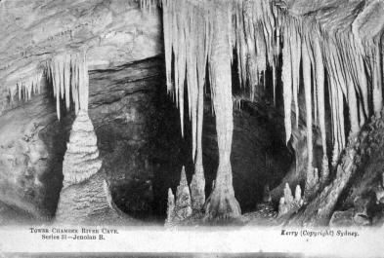
Design of JK31A | Design of JK31B, JK31C, JK31D
JK31A.1 Tower Chamber, River Cave H [pm.1 Nov.1907]
JK31A.2 The Giant Sapphires, Orient Cave H [pm.29 Apr.1908]
JK31A.3 Empress Grotto, Orient Cave V [ms.1908]
JK31A.4 Bath of Venus, Skeleton Cave V [pm.29 Apr.1908]
JK31A.5 The Oberon Grotto,/Skeleton Cave V
JK31A.6 Suspended Crystals./Orient Cave V [pm.Mar.1909]
JK31A.7 Gem of the South, Temple of Baal V [pm.27 Apr.1909]
JK31A.8 The Indian Chamber, Orient Cave V [pm.10 Apr.1907]
JK31A.9 The Lyre Bird's Nest,/Orient Cave V
JK31A.10 The White Temple, River Cave V [pm.10 Apr.1907]
(Attributed to Trickett in his Guide)
One card [pm.16 Jan.1909] contains the balance of the letter from JK01B.6 (see above), which continues, '. . . and charge 5/- each visit. . . the Grand Arch is very high and the rocks go up straight for about 300 feet. . . . We can freewheel for 5 miles from where we are stopping to the caves but you have to push 5 miles back, we are going to Lithgow after we leave here to see the iron works.' [probably from the two young men who pedalled penny-farthings around Australia!
JK31A.11 Angel's Wing, Orient Cave V
JK31A.12 The Nymph's Baths, River Cave V [pm.21 Apr.1906]

The above series was sold in a printed package, the labelling of which included the words 'Copyright Strictly Vested in Kerry & Co., 310 George St., Sydney.' | 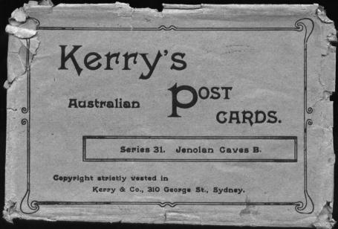

JK31B.1 [Tower Chamber, River Cave] H [pm.23 Dec.1908]
JK31B.2 [The Giant Sapphires, Orient Cave] H
JK31B.3 [Empress Grotto, Orient Cave] V [pm 30 Apr. 1908]
JK31B.4 [Bath of Venus, Skeleton Cave] V
One card has written on back '...This is a portion of the underground river, the water of which is icy cold. In the river are most peculiar looking fish without any eyes.' This reference is of interest: there is no authenticated record of blind fish at Jenolan, but there are various early rumours - these probably represent an expectation by the guides rather than reality.
JK31B.5 [Oberon Grotto, Skeleton Cave] V [pm.8 June 1908]
JK31B.6 [Suspended Crystals, Orient Cave] V
JK31B.7 [Gem of the South, Temple of Baal] V [pm.21 Jul.1909]
JK31B.8 [Indian Chamber, Orient Cave] V [pm.23 May 1907]
JK31B.9 [Lyre Bird's Nest] V

JK31B.10 [The White Temple, River Cave] V
[Attributable to Trickett]
We have seen one remarkable example of this card, dated on 23rd May 1908 and signed on the picture side by J.C. (Jack) Edwards, Jenolan cave guide and exploring partner of J.C. Wiburd.
JK31B.11 [Angel's Wing, Orient Cave] V
JK31B.12 [The Nymph's Baths, River Cave] V

JK31C.1 Tower Chamber River Cave H [pm.23 Mar.1906]
JK31C.2 The Giant Sapphires, Orient Cave H [pm.23 Mar.1906]
JK31C.3 Empress Grotto, Orient Cave V [pm.20 Feb.1906]
JK31C.4 Bath of Venus, Skeleton Cave V [pm.23 Mar.1906]
JK31C.5 The Oberon Grotto, Skeleton Cave V [pm.23 Mar.1906]
JK31C.6 Suspended Crystals, Orient Cave V [pm.8 Mar.1906]
JK31C.7 Gem of the South, Temple of Baal V [pm.1 Nov.1905]
JK31C.8 The Indian Chamber, Orient Cave V [pm.23 Mar.1906]
JK31C.9 The Lyre Bird's, Nest Orient Cave, V (sic) [pm.23 Mar.1906]
JK31C.10 The White Temple, River Cave V [pm.27 Mar.1906]
(Attributable to Trickett)
JK31C.11 Angel's Wing, Orient Cave V [pm.23 Mar.1906]
JK31C.12 The Nymph's Baths, River Cave V [pm.7 Mar.1905]

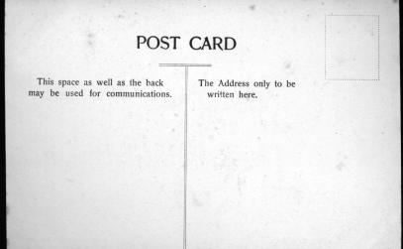 | 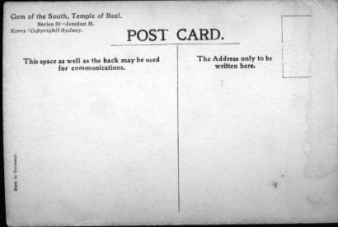
Back of JK31D | Back of JK31E. Title at upper right is printed in red.

JK31D.1 Tower Chamber River Cave H
JK31D.2 The Giant Sapphires, Orient Cave H
JK31D.3 Empress Grotto, Orient Cave V
JK31D.4 Bath of Venus, Skeleton Cave V
JK31D.5 The Oberon Grotto, Skeleton Cave V
JK31D.6 Suspended Crystals, Orient Cave V
JK31D.7 Gem of the South, Temple of Baal V [pm.8 Dec.1909]
JK31D.8 The Indian Chamber, Orient Cave V
Sender says 'This is a view of one of the beautiful spots in the caves. We arrived by coach yesterday. . . . now we are at the caves which is the best of our trip. The postcard is a beautiful site. The white hanging is just as clear and as white as straw, and has lovely pink tints running through it and the columns are just like glittering diamonds.'

JK31D.9 The Lyre Birds, Nest Orient Cave (sic) V [pm.22 Feb.1907]
Message on back says 'This is a specimen of Jenolan Caves supposed to be finest in the world. I visited 4 of them took 2 hours each ...'
JK31D.10 The White Temple, River Cave V
(s.n.a. 5.10, attributable to Trickett)
JK31D.11 Angel's Wing, Orient Cave V [pm.2 Mar.1909]
This and the following card are both from the same sender but to two different addressees. This one notes 'we have seen three caves . . . River Cave. The last was the most interesting as we were ferried across the River Styx, the guide taking the place of Charon.'
JK31D.12 The Nymph's Baths, River Cave V [pm.2 Mar.1909]
Sender says '. . .We had a two days' walk (36 miles) to get here - a party of 7, 6 girls & a chaperone - had great fun on the way. We are seeing as many caves as we can get in, in the time & expect to leave here Thursday for a walkback on a different road.' This is interesting evidence of early walking tours by women; see also notes below on the Six-foot Track.

JK31E.3 Empress Grotto, Orient Cave V
JK31E.7 Gem of the South, Temple of Baal V

It will be seen from the above that all 12 designs have been recorded in each of the first four sub-series, but to date, only two in the fifth.

JK 76. Kerry Series 76 [Lucas Cave] [1908-11?]

Ph Charles Kerry
Pu Kerry & Co.
Pr In Germany by collotype
F Printed from photographs in six styles as below

Title in large type with serifs
- double dividing line on back 76A
- single dividing line on back 76B
Title in small type with serifs
- word 'postcard' is 32mm. long 76C
- word 'postcard' is 35mm. long 76D
Title in large sans-serif type
- word 'postcard' is 32mm. long 76E
- word 'postcard' is 35mm. long 76F

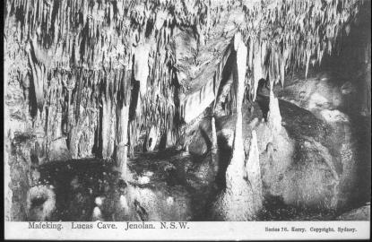 | 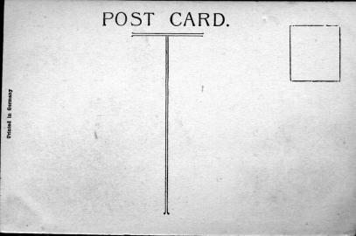
Front and Back of JK76A

JK76A.1 Mafeking. Lucas Cave. Jenolan. N.S.W. H
JK76A.4 Snowball Cave. Lucas. Jenolan. N.S.W. V
JK76A.5 Broken Column. Lucas Cave. Jenolan. N.S.W. V
JK76A.6 Crystal Fountain. Lucas Cave. Jenolan. N.S.W. V
JK76A.7 The Minaret. Lucas Cave. Jenolan. N.S.W. V (s.n.a.00.14)
JK76A.8 Proscenium. Lucas Cave. Jenolan. N.S.W. V
JK76A.9 Exhibition Chamber. Lucas Cave. Jenolan. N.S.W. V
JK76A.10 The Curtain. Lucas Cave. Jenolan. N.S.W. V
JK76A.11 Mafeking. Lucas Cave. Jenolan. N.S.W. V (s.n.a. 00.9)
[pm.7 Jan.1910]
JK76A.12 Bone Cave. Lucas. Jenolan. N.S.W. V

JK76B.1 Mafeking. Lucas Cave. Jenolan. N.S.W. H
JK76B.2 Coral Grotto. Lucas Cave. Jenolan. N.S.W. H (s.n.a. 00.1)
JK76B.3 Tower Chamber. Lucas Cave. Jenolan. N.S.W. H (s.n.a. 31.1)
JK76B.4 Snowball Cave. Lucas. Jenolan. N.S.W. V
JK76B.5 Broken Column. Lucas Cave Jenolan. N.S.W. V
JK76B.6 Crystal Fountain. Lucas Cave. Jenolan. N.S.W. V
JK76B.7 The Minaret. Lucas Cave. Jenolan. N.S.W. V (s.n.a.00.14)
[pm. n.e.1913]
JK76B.8 Proscenium. Lucas Cave. Jenolan. N.S.W. V [pm.9 Mar. 1915]
JK76B.9 Exhibition Chamber. Lucas Cave. Jenolan. N.S.W. V
JK76B.10 The Curtain. Lucas Cave. Jenolan. N.S W. V
JK76B.11 Mafeking. Lucas Cave. Jenolan. N.S.W. V (s.n.a. 00.9)
JK76B.12 Bone Cave. Lucas. Jenolan. N.S.W. V [ms.12 Mar.1913]

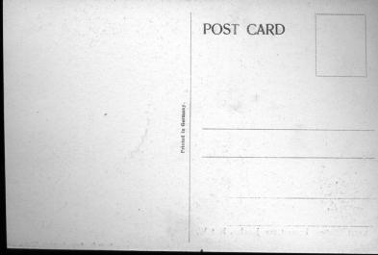 | 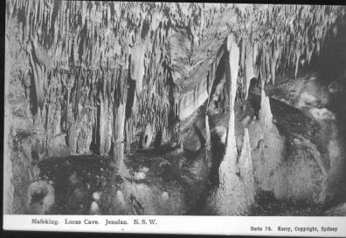
Back of JK76B | Design of JK76C & JK76D

JK76C.1 Mafeking. Lucas Cave. Jenolan. N.S.W. H
JK76C.2 Coral Grotto. Lucas Cave. Jenolan. N.S.W. H (s.n.a. 00.1)
JK76C.4 Snowball Cave. Lucas. Jenolan. N.S.W. V
JK76C.6 Crystal Fountain. Lucas Cave. Jenolan. N.S.W. V
JK76C.11 Mafeking. Lucas Cave. Jenolan. N.S.W. V (s.n.a. 00.9)
[pm.28 Sep.1911]
JK76C. 12 Bone Cave. Lucas. Jenolan. N.S.W. V

JK76D.1 Mafeking. Lucas Cave. Jenolan. N.S.W. H
JK76D.2 Coral Grotto. Lucas Cave. Jenolan. N.S.W. H (s.n.a. 00.1)
JK76D.3 Tower Chamber. Lucas Cave. Jenolan. N.S.W. H (s.n.a. 31.1)
JK76D.4 Snowball Cave. Lucas. Jenolan. N.S.W. V
JK76D.5 Broken Column. Lucas Cave. Jenolan. N.S.W. V
JK76D.6 Crystal Fountain. Lucas Cave. Jenolan. N.S.W. V
JK76D.7 The Minaret. Lucas Cave. Jenolan. N.S.W. V (s.n.a.00.14)
JK76D.8 Proscenium. Lucas Cave. Jenolan. N.S.W. V
JK76D.9 Exhibition Chamber. Lucas Cave. Jenolan. N.S.W. V
[pm.5 Dec.1911]
JK76D.10 The Curtain. Lucas Cave. Jenolan. N.S.W. V
JK76D.11 Mafeking. Lucas Cave. Jenolan. N.S.W. V (s.n.a. 00.9)
JK76D.12 Bone Cave. Lucas. Jenolan. N.S.W. V [pm.19 Feb.1913]

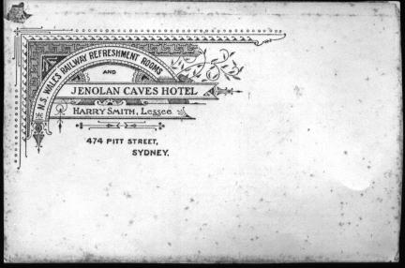 | 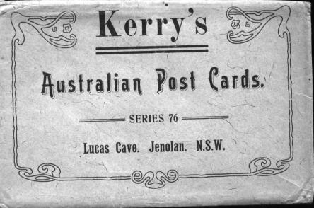
Series JK76D was sold as a packaged set with the imprint of Harry Smith, Lessee of Caves House and separately with that of Kerry.

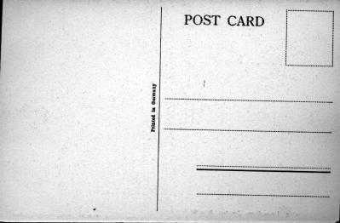 | Back of JK76C and JK76D

JK76E.9 Exhibition Chamber. Lucas Cave. Jenolan. N.S.W. V

JK76F.1 Mafeking. Lucas Cave. Jenolan. N.S.W. H
JK76F.2 Coral Grotto. Lucas Cave. Jenolan. N.S.W. H (s.n.a. 00.1)
JK76F.3 Tower Chamber. Lucas Cave. Jenolan. N.S.W. H (s.n.a. 31.1)
JK76F.4 Snowball Cave. Lucas. Jenolan. N.S.W. V
JK76F.5 Broken Column. Lucas Cave. Jenolan. N.S.W. V
JK76F.6 Crystal Fountain. Lucas Cave. Jenolan. N.S.W. V
JK76F.7 The Minaret. Lucas Cave. Jenolan. N.S.W. V (s.n.a.00.14)
JK76F.8 Proscenium. Lucas Cave. Jenolan. N.S.W. V
JK76F.10 The Curtain. Lucas Cave. Jenolan. N.S.W. V
JK76F.11 Mafeking. Lucas Cave. Jenolan. N.S.W. V
JK76F.12 Bone Cave. Lucas. Jenolan. N.S.W. V

Note : Coral Grotto is actually in Imperial Cave, and the Minaret in River Cave.

SUMMARY : Jenolan JK76 - Cards known to date.

 |  | A | B | C | D | E | F
JK76.1 | Mafeking H | * | * | * | * |  | *
JK76.2 | Coral Grotto |  | * | * | * |  | *
JK76.3 | Tower Chamber |  | * |  | * |  | *
JK76.4 | Snowball | * | * | * | * |  | *
JK76.5 | Broken Column | * | * |  | * |  | *
JK76.6 | Crystal Fountain | * | * | * | * |  | *
JK76.7 | Minaret | * | * |  | * |  | *
JK76.8 | Proscenium | * | * |  | * |  | *
JK76.9 | Exhibition | * | * |  | * | *
JK76.10 | Curtain | * | * |  | * |  | *
JK76.11 | Mafeking V | * | * | * | * |  | *
JK76.12 | Bone Cave | * | * | * | * |  | *

JK77. Kerry Series JK77 [Left Imperial] [1908-11?]

Note : In 1952, this cave was re-named the Chifley Cave.

Ph Charles Kerry
Pu Kerry & Co.
Pr In Germany by collotype
F Printed from photographs in two styles as below.

Double dividing line on back JK77A
Single dividing line on back JK77B

JK77A.1 Architect's Studio. Left Imperial. Jenolan. N.S.W. V
[pm.17 Apr.1911]
JK77A.2 Madonna Cave. Left Imperial. Jenolan. N.S.W. V
JK77A.3 Marguerite Cave. Left Imperial. Jenolan. N.S.W. V
JK77A.4 The Mystery. Left Imperial. Jenolan. N.S.W. V
JK77A.5 Bone Cave. Left Imperial. Jenolan. N.S.W. H
JK77A.6 Wilkinson Cave. Left Imperial. Jenolan. N.S.W. H
JK77A.7 The Shambles. Left Imperial. Jenolan. N.S.W. H
JK77A.8 Lucinda Cave. Left Imperial. Jenolan. N.S.W. H (s.n.a. 00.3)
JK77A.9 Madonna Cave, Left Imperial. Jenolan. N.S.W. H
JK77A.10 Coral Cave. Left Imperial. Jenolan. N.S.W. H
JK77A.11 Snowdrift. Left Imperial. Jenolan. N.S.W. H
JK77A.12 Katie's Bower. Left Imperial. Jenolan. N.S.W. V (s.n.a. 00.12)

JK77B.2 Madonna Cave. Left Imperial. Jenolan. N.S.W. V
JK77B.3 Marguerite Cave. Left Imperial. Jenolan. N.S.W. V
The back of this card is inscribed 'Bobby Seaton/for spelling/14.9.34', indicating that it was used as a reward for school performance. This was not uncommon, and the London Education Authority even had a number of postcards reprinted with a special 'reward-card' back for this purpose (Anon. 19JK85) See below for an example.
JK77B.5 Bone Cave. Left Imperial. Jenolan. N.S.W. H
JK77B.7 The Shambles. Left Imperial. Jenolan. N.S.W. H
JK77B.8 Lucinda Cave. Left Imperial. Jenolan. N.S.W. H
JK77B.10 Coral Cave. Left Imperial. Jenolan. N.S.W. H
JK77B.11 Snowdrift. Left Imperial. Jenolan. N.S.W. H
JK77B.12 Katie's Bower. Left Imperial. Jenolan. N.S.W. H

JK77B Special card –The Shambles, Stockton-on-Tees  A higher cavern in the Chifley Cave are commonly known as the Shambles. One can only assume that it was named after the contemporary British name for a meat market, used throughout much of the United Kingdom. This area of the cave is no longer open for general tours, but as it still has the original electrical fittings, it is sometimes used for historic tours. | 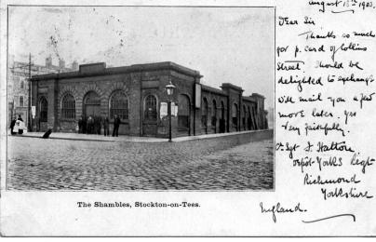

JK77B Special card – an example of the LEA reward cards  We also have an example in our series 8 where a card was used as an award in schooling. Here is a card depicting a major bridge and marina at Geneva with a specially printed back for use as a reward by the schools of the London County Council. | 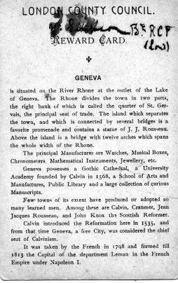

SUMMARY : Jenolan JK77 - Cards known to date

 |  | A | B
JK77.1 | Architect’s Studio | *
JK77.2 | Madonna V | * | *
JK77.3 | Marguerite | * | *
JK77.4 | Mystery | *
JK77.5 | Bone Cave | * | *
JK77.6 | Wilkinson | *
JK77.7 | The Shambles | * | *
JK77.8 | Lucinda | * | *
JK77.9 | Madonna H | *
JK77.10 | Coral Cave | * | *
JK77.11 | Snowdrift | * | *
JK77.12 | Katie’s Bower | * | *

JK78. Kerry Series JK78 [Right Imperial] [1908-10?]

Note : Since the re-naming of the Left Imperial, this cave
has been known simply as the Imperial.

Ph Charles Kerry
Pu Kerry & Co.
Pr In Germany by collotype

F Printed from photographs in six different styles as
below.

Title in large type with serifs/back with double dividing line
- stamp box in solid lines JK78A
- stamp box in dotted lines JK78B
Title in small sans-serif type/back with single dividing line
- word 'post-card' is 32 mm. long JK78C
- word 'post-card' is 35 mm. long JK78D
- back printed in green with serial number
in stamp box JK78E
Title and imprint on back JK78F

NOTE : Although the Wilkinson Cave is included in this
series, it is actually part of the Left Imperial (Chifley) , and so is properly placed in Jenolan JK77 above, where it also appears.
.
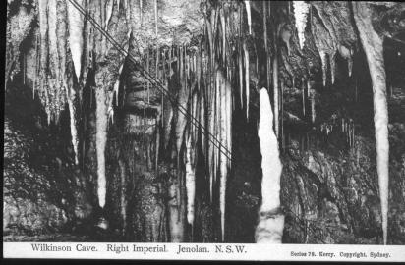 | 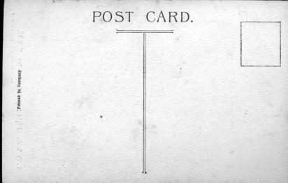
Back and Front of JK78A

JK78A.3 Wilkinson Cave. Right Imperial. Jenolan. N.S.W. H (s.n.a. JK77.6) [pm.17 Jan.1911]
Sender says, 'We have been to the Blue Mountains seeing the wonderful caves there a sight I have been longing to see it is one I shall never forget. The view on this card we saw on our first inspection. I thought them grand, but they were nothing to what we saw after in another cave. We crossed an underground river 600 feet below the surface of the earth it was like a trip into fairyland. When the lights were turned on the river is 16 feet deep and ice-cold so it would not do to fall in. The boat is . . .'
JK78A.6 Underground River. Right Imperial. Jenolan. N.S.W. H (s.n.a. 01.1)
JK78A.7 Crystal Palace. Right Imperial. Jenolan. N.S.W. V [pm.15 Nov.1910]
(s.n.a. 0.1)
JK78A.9 Gem of the West. Right Imperial. Jenolan. N.S.W. V
JK78A.11 Crystal Cities. Right Imperial. Jenolan. N.S.W. H [pm.21 Dec.1910]
JK78A.12 Nellie's Grotto. Right Imperial. Jenolan. N.S.W. H (s.n.a. 0.2)
[pm.11 Feb.1910]
Message reads '...We walked from caves to Lithgow 30 miles. We did it in 8 hours...'

JK78B.1 Lot's Wife. Right Imperial. Jenolan. N.S.W. V
JK78B.2 Confectioners Shop. Right Imperial. Jenolan. N.S.W. V
JK78B.4 Gem of the West. Right Imperial. Jenolan. N.S.W. V (s.n.a. 00.16)
JK78B.5 Shawls. Right Imperial. Jenolan. N.S.W. V
JK78B.8 Grand Stalactites. Right Imperial. Jenolan. N.S.W. V
JK78B.10 Show Room. Right Imperial. Jenolan. N.S.W. V (s.n.a. 01.8)
[pm.9 Jul.1910]
It appears that these two are simply a single series with two differing backs. See also in JK78C and JK78D.

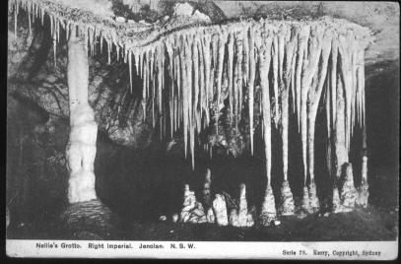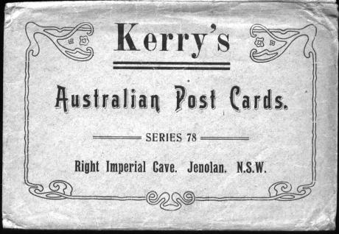
Design of JK78C, together with package.
NOTE : Cards # 3,10 & 12 of series JK78C were sold in a packaged set along
with cards 1,2,4,5,6,7,8,9 & 11 of series 9D. However, Series JK78C also were
sold intact as a packaged set. Both used a Type 2 package.

JK78C.2 Confectioners Shop. Right Imperial. Jenolan. N.S.W. V
JK78C.3 Wilkinson Cave. Right Imperial. Jenolan. N.S.W. H (s.n.a. JK77.6)
JK78C.4 Gem of the West. Right Imperial. Jenolan. N.S.W. V (s.n.a. 00.16)
JK78C.5 Shawls. Right Imperial. Jenolan. N.S.W. V
JK78C.6 Underground River. Right Imperial. Jenolan. N.S.W. H (s.n.a. 01.1)
[pm.11 Dec.1913]
JK78C.7 Crystal Palace. Right Imperial. Jenolan. N.S.W. V (s.n.a. 0.1)
JK78C.8 Grand Stalactites. Right Imperial. Jenolan. N.S.W. V
JK78C.9 Gem of the West. Right Imperial. Jenolan. N.S.W. V (s.n.a. 00.8)
JK78C.10 Show Room. Right Imperial. Jenolan. N.S.W. V (s.n.a. 01.8)
JK78C.11 Crystal Cities. Right Imperial. Jenolan. N.S.W. H
JK78C.12 Nellie's Grotto. Right Imperial. Jenolan. N.S.W. H (s.n.a. 0.2)
[ms.20 Jan.1920]

JK78D.1 Lot's Wife. Right Imperial. Jenolan. N.S.W. V [pm.11 Dec.1913]
JK78D.2 Confectioners Shop. Right Imperial. Jenolan. N.S.W. V
JK78D.4 Gem of the West. Right Imperial. Jenolan. N.S.W. V (s.n.a. 00.16)
JK78D.5 Shawls. Right Imperial. Jenolan. N.S.W. V
JK78D.6 Underground River. Right Imperial. Jenolan. N.S.W. H (s.n.a. 01.1)
[pm.11 Dec.1913]
JK78D.7 Crystal Palace. Right Imperial. Jenolan. N.S.W. V (s.n.a. 0.1)
JK78D.8 Grand Stalactites. Right Imperial. Jenolan. N.S.W. V
JK78D.9 Gem of the West. Right Imperial. Jenolan. N.S.W. V (s.n.a. 00.8)
JK78D.11 Crystal Cities. Right Imperial. Jenolan. N.S.W. H

Our series JK78E is the only one of Kerry's numbered Jenolan series in which each card also has an individual number  (Listed below). Note also that the full stops that appeared in the titles of the other sub-series have in this group been  replaced with commas. | 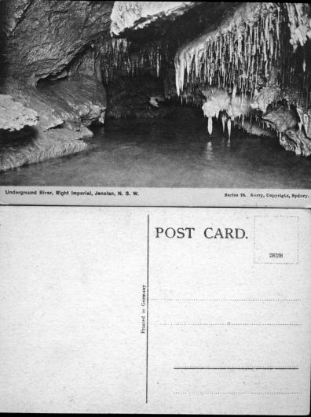

JK78E.1 2JK8338 Lot's Wife, Right Imperial, Jenolan, N.S.W. V
[pm.11 Dec.1913]
JK78E.2 2JK8339 Confectioners Shop, Right Imperial, Jenolan, N.S.W. V
JK78E.3 2JK8340 Wilkinson Cave, Right Imperial, Jenolan, N.S.W. H
(s.n.a. JK77.6)
JK78E.4 2JK8341 Gem of the West, Right Imperial, Jenolan, N.S.W. V
(s.n.a. 00.16)
JK78E.5 2JK8342 Shawls, Right Imperial, Jenolan, N.S.W. V
JK78E.6 2JK8343 Underground River, Right Imperial, Jenolan, N.S.W. H
(s.n.a. 01.1) [pm.11 Dec.1913]
JK78E.7 2JK8344 Crystal Palace, Right Imperial, Jenolan, N.S.W. V (s.n.a. 0.1)
JK78E.8 2JK8345 Grand Stalactites, Right Imperial, Jenolan, N.S.W. V
JK78E.9 2JK8346 Gem of the West, Right Imperial, Jenolan, N.S.W. V
(s.n.a. 00.8) [pm.31 Mar.1915]
JK78E. 10 2JK8347 Show Room, Right Imperial, Jenolan, N.S.W. V (s.n.a. 4.8)
JK78E. 11 2JK8348 Crystal Cities, Right Imperial, Jenolan, N.S.W. H
[pm.12 Aug.1912]
JK78E.12 2JK8349 Nellie's Grotto, Right Imperial, Jenolan, N.S.W. H (s.n.a.2.2)

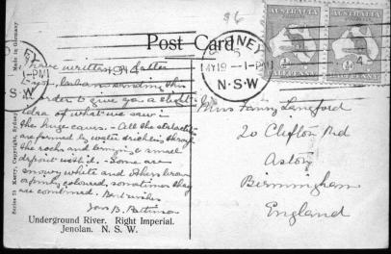 | The back of JK78F note title at lower left of card.

JK78F.1 2JK8338 Lot's Wife, Right Imperial, Jenolan, N.S.W. V
JK78F.2 2JK8339 Confectioners Shop, Right Imperial, Jenolan, N.S.W. V
JK78F.4 Gem of the West, Right Imperial, Jenolan, N.S.W. V
(s.n.a. 00.16)
JK78F.5 Shawls, Right Imperial, Jenolan, N.S.W. V
JK78F.6 Underground river, Right Imperial/Jenolan, N.S.W. H [pm.1914]
JK78F.7 Crystal Palace, Right Imperial, Jenolan, N.S.W. V (s.n.a. 2.1)
JK78F.8 Grand Stalactites, Right Imperial, Jenolan, N.S.W. V
JK78F.9 Gem of the Mst (sic), Right Imperial, Jenolan, N.S.W. V
(s.n.a. 3.8)
Note erroneous spelling: (“Gem of the Mst” for “Gem of the West”)
JK78F.10 Show Room, Right Imperial, Jenolan, N.S.W. V (s.n.a. 4.8)
JK78F.12 Nellie's Grotto, Right Imperial, Jenolan, N.S.W. H (s.n.a.2.2)

SUMMARY : Jenolan JK78 - Cards known to date

 |  | A | B | C | D | E | F
JK78.1 | Lot’s Wife |  | * |  | * | * | *
JK78.2 | Confectioner’s Shop |  | * |  | * | * | *
JK78.3 | Wilkinson | * |  | * |  | *
JK78.4 | Gem of the West |  | * |  | * | * | *
JK78.5 | Shawls |  | * |  | * | * | *
JK78.6 | Underground River | * |  |  | * | * | *
JK78.7 | Crystal Palace | * |  |  | * | * | *
JK78.8 | Grand Stalactites |  | * |  | * | * | *
JK78.9 | Gem of the West | * |  |  | * | * | *
JK78.10 | Show Room |  | * | * |  | * | *
JK78.11 | Crystal Cities | * |  |  | * | *
JK78.12 | Nellie’s Grotto | * |  | * |  | * | *

JK79. Kerry Series JK79 [Jenolan Landscapes] [1908-11?]

Ph Charles Kerry
Pu Kerry & Co.
Pr In Germany by collotype
F Printed from photographs in four different styles.

Double dividing line on back JK79A
Single dividing line on back
- words 'Post Card' to right of centre
- 'Post Card' is 29 mm. long JK79B
- 'Post Card' is 25 mm. long JK79C
- words 'Post Card' are centred JK79D

JK79A.1 Cave's House. Jenolan. N.S.W. H [pm.11 Feb.1913]
(This card depicts Caves House as seen from the entrance roadway. On the left is a small kiosk with an advertisement for Kerry postcards, conspicuously located on the wall. Two people are standing nearby and a small dog, which appears in various Jenolan photographs, is sitting in the road.)
JK79A.2 Grand Arch. Jenolan. N.S.W. H
JK79A.3 Grand Arch. Jenolan. N.S.W. H (s.n.a. 00.7) [pm.29 Apr. 1911]
JK79A.4 Lucas Rocks. Jenolan. N.S.W. V [ms.9-11 Feb.1910]
JK79A.5 The River. Jenolan. N.S.W. V [ms.9-11 Feb.1910]
JK79A.6 The Reservoir. Jenolan. N.S.W. V
JK79A.7 Carlotta Arch. Jenolan. N.S.W. V (s.n.a. 00.15 : view from below)
[ms.9-11 Feb.1910]
JK79A.8 Carlotta Arch. Jenolan. N.S.W. V (view from above)
JK79A.9 View from Lucas Cave. Jenolan. N.S.W. V
JK79A.10 Devil's Coach House. Jenolan. N.S.W. V [pm.1 May 1911]
JK79A.11 Grand Arch. Jenolan. N.S.W. V (s.n.a. 00.13 : view with bridge)
JK79A.12 Entrance Nettle and Arch Cave. Jenolan. N.S.W. V

Series JK79A was sold as a packaged set (Type 2). | 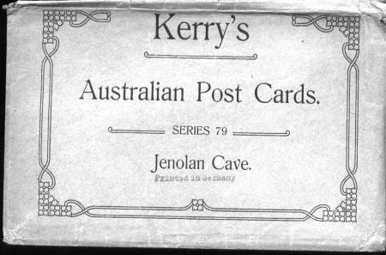

JK79B.4 Lucas Rocks. Jenolan. N.S.W. V
JK79B.5 The River. Jenolan. N.S.W. V
JK79B.6 The Reservoir. Jenolan. N.S.W. V
JK79B.7 Carlotta Arch. Jenolan. N.S.W. V (view from below)
JK79B.8 Carlotta Arch. Jenolan. N.S.W. V (view from above)
JK79B.9 View from Lucas Cave. Jenolan. N.S.W. V
JK79B.11 Grand Arch. Jenolan. N.S.W. V (s.n.a. 00.13)
JK79B.12 Entrance Nettle and Arch Cave. Jenolan. N.S.W. V

JK79C.1 Caves House. Jenolan. N.S.W. H
JK79C.2 Grand Arch. Jenolan. N.S.W. H
JK79C.3 Grand Arch. Jenolan. N.S.W. H (s.n.a. 00.7)
JK79C.4 Lucas Rocks. Jenolan. N.S.W. V
JK79C.5 The River. Jenolan. N.S.W. V
JK79C.6 The Reservoir. Jenolan. N.S.W. V
JK79C.7 Carlotta Arch. Jenolan. N.S.W. V (s.n.a. 00.15 : view from below)
JK79C.8 Carlotta Arch. Jenolan. N.S.W. V (view from above)
JK79C.9 View from Lucas Cave. Jenolan. N.S.W. V
JK79C.10 Devil's Coach House. Jenolan. N.S.W. V
JK79C.11 Grand Arch. Jenolan. N.S.W. V (s.n.a. 3.13 : view with bridge)
JK79C.12 Entrance Nettle and Arch Cave. Jenolan. N.S.W. V
[ms.4 Mar.1914]

Series JK79C was also sold in a package (Type 3- see other series below).

The distinctive back of JK79D cards | 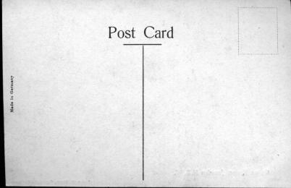

JK79D.1 Caves House. Jenolan. N.S.W. H
JK79D.2 Grand Arch. Jenolan. N.S.W. H
JK79D.3 Grand Arch. Jenolan. N.S.W. H (s.n.a. 00.7)
JK79D.4 Lucas Rocks. Jenolan. N.S.W. V
JK79D.5 The River. Jenolan. N.S.W. V
JK79D.6 The Reservoir. Jenolan. N.S.W. V
JK79D.7 Carlotta Arch. Jenolan. N.S.W. V (s.n.a. 00.15 : view from below)
JK79D.9 View from Lucas Cave. Jenolan. N.S.W. V
JK79D.11 Grand Arch. Jenolan. N.S.W. V (s.n.a. 00.13 : view with bridge)
JK79D.12 Entrance Nettle and Arch Cave. Jenolan. N.S.W. V

SUMMARY : Jenolan JK79- cards to date

 |  | A | B | C | D
JK79.1 | Caves House | * |  | * | *
JK79.2 | Grand Arch | * |  | * | *
JK79.3 | Grand Arch | * |  | * | *
JK79.4 | Lucas Rocks | * | * | * | *
JK79.5 | The River | * |  | * | *
JK79.6 | The Reservoir | * |  | * | *
JK79.7 | Carlotta Arch | * |  | * | *
JK79.8 | Carlotta Arch | * |  | *
JK79.9 | View from Lucas Cave | * | * | * | *
JK79.10 | Devil’s Coach House | * |  | *
JK79.11 | Grand Arch | * | * | * | *
JK79.12 | Entrance Nettle & Arch | * | * | * | *

JK80. Kerry Series JK80 [Jubilee Cave]

Ph Charles Kerry
Pu Kerry & Co.
Pr In Germany by Collotype
F As Jenolan 76.

JK80.1 Paradise. Jubilee Cave. Jenolan. N.S.W. H
JK80.2 The Dome. Jubilee Cave. Jenolan. N.S.W. H
JK80.3 The Curios. Jubilee Cave. Jenolan. N.S.W. H
JK80.4 The Pincushion. Jubilee Cave. Jenolan. N.S.W. H
JK80.5 Gwendolin’s Bower. Jubilee Cave. Jenolan. N.S.W. H
JK80.6 Staghorns. Jubilee Cave. Jenolan. N.S.W. V
JK80.7 Victoria Bower. Jubilee Cave. Jenolan. N.S.W. V
JK80.8 Mysteries. Jubilee Cave. Jenolan. N.S.W. V
JK80.9 Alabaster Hall. Jubilee Cave. Jenolan. N.S.W. V
JK80.10 Paradise. Jubilee Cave. Jenolan. N.S.W. V
JK80.11 The Red Cave. Jubilee Cave. Jenolan. N.S.W. V

Kerry (1908) also lists Gem of Jenolan in this series.

JK81. Kerry Series JK81 [Nettle and Arch Cave] [1908-14?]

Ph Charles Kerry
Pu Kerry & Co.
Pr In Germany by Collotype
F Two styles as below

Double dividing line on back JK81A
Single dividing line on back JK81B

JK81A.1 Steps to Arch Cave. Jenolan. N.S.W. H
JK81A.2 Ball Room. Devil's Coach House. Jenolan. N.S.W. H
(actually part of Nettle Cave) [pm. 12 Mar. 1912]
JK81A.3 Arch Cave. Jenolan. N.S.W. V
JK81A.4 The Willows. Nettle Cave. Jenolan. N.S.W. V [pm. 11 Jul. 1913]
JK81A.5 Grand Chamber. Nettle Cave. Jenolan. N.S.W. V
JK81A.6 Sculptor's Studio. Nettle Cave. Jenolan. N.S.W. V
[ms.22 Dec.1915]

JK81B.1 Steps to Arch Cave. Jenolan. N.S.W. H
JK81B.2 Ball Room. Devil's Coach House. Jenolan. N.S.W. H
JK81B.3 Arch Cave. Jenolan. N.S.W. V
JK81B.4 The Willows. Nettle Cave. Jenolan. N.S.W. V
JK81B.5 Grand Chamber, Nettle Cave, Jenolan N.S.W. V
JK81B.6 Sculptor's Studio. Nettle Cave. Jenolan. N.S.W. V [pm.2 Apr.1914]

JK82. Kerry Series JK82 (Skeleton Cave) [1908?]

Note : As a result of various protests, the skeleton is no longer exhibited to the public, and the tour has been re-named Cerberus Cave.

Ph Charles Kerry
Pu Kerry & Co.
Pr In Germany by collotype
F Printed from photographs in two styles as below

Double dividing line on back: JK82A
Single Dividing line on back: JK82B

JK82A.1 Bath of Venus. Skeleton Cave. Jenolan. N.S.W. H
JK82A.2 Bath of Venus. Skeleton Cave. Jenolan. N.S.W. V (s.n.a. 31.4)
JK82A.3 Oberon Grotto. Skeleton Cave. Jenolan. N.S.W. V (s.n.a. 31.5)
JK82A.4 Den of Cerberus. Skeleton Cave. Jenolan. N.S.W. V
[J.C. Wiburd is depicted on this card.]
JK82A.5 The Arabesque. Skeleton Cave. Jenolan. N.S.W. V
JK82A.6 Aboriginal Skeleton. Skeleton Cave. Jenolan. N.S.W. V

JK82B.1 Bath of Venus, Skeleton Cave, Jenolan N.S.W. H
JK82B.2 Bath of Venus. Skeleton Cave. Jenolan. N.S.W. V (s.n.a. 31.4)
JK82B.3 Oberon Grotto, Skeleton Cave, Jenolan. N.S.W. V (s.n.a. 31.5)
JK82B.4 Den of Cerberus, Skeleton Cave, Jenolan. N.S.W. V
JK82B.5 The Arabesque, Skeleton Cave, Jenolan. N.S.W. V
Sender says 'We saw the skeleton of a black man who
was 7 ft in height and had lived 6000 years ago. How would
you like to be as tall as that ?' These figures suggest
considerable imagination being used by the guides !
JK82B.6 Aboriginal Skeleton. Skeleton Cave. Jenolan. N.S.W. V

This is the type 3 package, widely used for the later series. | 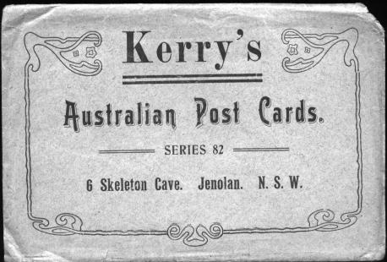

Both were sold as a packaged series ; JK82A in Type 2 and JK82B in Type 3. The series had a 'Printed in Germany' imprint, but it has been either trimmed or overprinted in
black in most of the cards we have seen.

JK83. Kerry Series JK83 [Orient Cave] [1908-11?]

Ph Charles Kerry
Pu Kerry & Co.
Pr In Germany by collotype
F as JK76A
JK83.1 The Goblin's Basin. Orient Cave. Jenolan. N.S.W. H [pm.1911]
JK83.2 Persian Grotto. Orient Chamber. Jenolan. N.S.W. V
JK83.3 Indian Chamber. Orient Cave. Jenolan. N.S.W. V (s.n.a. 5.8)
JK83.4 Rippled Floor. Orient Cave. Jenolan. N.S.W. V
JK83.5 Saw Mysteries. Orient Cave. Jenolan. N.S.W. V
JK83.6 Lyre Birds Nest. Orient Cave. Jenolan. N.S.W. V (s.n.a. 5.9)
JK83.7 Suspended Crystals. Orient Cave. Jenolan. N.S.W. V (s.n.a. 5.6)
JK83.8 The Granit (sic) Sapphires. Orient Cave. Jenolan. N.S.W. V
(s.n.a. 5.2)
JK83.9 Empress Grotto. Orient Cave. Jenolan. N.S.W. V (s.n.a. 5.3)
JK83.10 Diana's Grotto. Orient Cave. Jenolan. N.S.W. V
JK83.11 Granny's Shawl. Orient Cave. Jenolan. N.S.W. V
JK83.12 Monument Mountain. Orient Cave. Jenolan. N.S.W. H

Interestingly, Kerry's un-dated pamphlet on Jenolan lists this series as having only 6 cards, but is clearly incorrect.

JK84. Kerry Series JK84 [Temple of Baal] [1908-11?]

Ph Charles Kerry
Pu Kerry & Co.
Pr In Germany by collotype
F Four formats as described:

Title in large type with serifs ; double dividing line on back JK84A
Title in large sans-serif type ; single dividing line on back
- 'Postcard' is 32 mm. long JK84B
- 'Postcard' is 35 mm. long
- Heavy underline in address panel JK84C
- Light underline only JK84D

JK84A.1 The Altar. Temple of Baal. Jenolan Caves. N.S.W. H
[pm.16 Mar.1910]
JK84A.2 Dragon's Den. Temple of Baal. Jenolan Caves. N.S.W. V
JK84A.3 Gem of the South. Temple of Baal. Jenolan Caves. N.S.W. V
(s.n.a. 31.7)
JK84A.4 Shawls. Temple of Baal. Jenolan Caves. N.S.W. V
[pm.27 Oct.1911]
JK84A.5 Ribbond (sic) Mysteries. Temple of Baal. Jenolan Caves. N.S.W. V
JK84A.6 Gem of the South. Temple of Baal. Jenolan Caves. N.S.W. V

JK84B.1 The Altar. Temple of Baal. Jenolan Caves. N.S.W. H
JK84B.5 Ribbond (sic) Mysteries. Temple of Baal. Jenolan Caves. N.S.W. V

JK84C.1 The Altar. Temple of Baal. Jenolan Caves. N.S.W. H
JK84C.2 Dragons Den. Temple of Baal. Jenolan Caves. N.S.W. V
JK84C.3 Gem of the South. Temple of Baal. Jenolan Caves. N.S.W. V
(s.n.a. 31.7)
JK84C.4 Shawls. Temple of Baal. Jenolan Caves. N.S.W. V
JK84C.5 Ribbond (sic) Mysteries. Temple of Baal. Jenolan Caves N.S.W. V
JK84C.6 Gem of the South. Temple of Baal. Jenolan Caves. N.S.W. V

JK84D.1 The Altar. Temple of Baal. Jenolan Caves. N.S.W. H
JK84D.2 Dragons Den. Temple of Baal. Jenolan Caves. N.S.W. V
JK84D.3 Gem of the South. Temple of Baal. Jenolan Caves. N.S.W. V
(s.n.a. 31.7)
JK84D.4 Shawls. Temple of Baal. Jenolan Caves. N.S.W. V
JK84D.5 Ribbond (sic) Mysteries. Temple of Baal. Jenolan Caves N.S.W. V
JK84C.6 Gem of the South. Temple of Baal. Jenolan Caves. N.S.W. V

Both Series JK84A & JK84D occur as packaged sets (Type 2). The cards generally have the printer's imprint erased, and as we will note in other places, this is probably the result of patriotic fervour during World War I. Kerry (1908) lists this series among his 'Penny Hand Coloured Cards', but we have only seen B. & W. examples.

SUMMARY: Jenolan JK84 - Cards known to date.

 |  | A | B | C | D
JK84.1 | Altar | * | * | * | *
JK84.2 | Dragon’s Den | * |  | * | *
JK84.3 | Gem of the South | * |  | * | *
JK84.4 | Shawls | * |  | * | *
JK84.5 | Ribond Mysteries | * | * | * | *
JK84.6 | Gem of the South | * |  | * | *

JK85. Kerry Series JK85 [River Cave] [1908-13?]

Ph Charles Kerry (except that JK85.4 & JK85.11 are both attributable to Trickett)
Pu Kerry & Co.
Pr In Germany by collotype
F Printed from photographs in four styles as below:

Title in large type with serifs; double dividing line on back JK85A
Title in large sans-serif type; single dividing line on back
- 'Postcard' is 32mm. long JK85B
- 'Postcard' is 35mm. long
- heavy underline in address panel JK85C
- light underline only JK85D

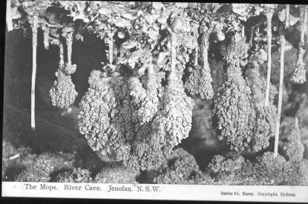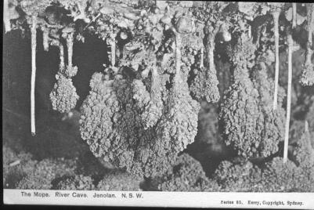
Design of JK85A | Design of JK85B, JK85C, JK85D

JK85A.1 The Mops, River Cave, Jenolan, N.S.W. H [pm.8 Nov.1911]
JK85A.2 The Punt, River Cave, Jenolan, N.S.W. H
(J.C. Wiburd is seated at L.H. end of punt)
JK85A.3 Nymph's Baths, River Cave, Jenolan, N.S.W. V (s.n.a. 31.12)
JK85A.4 The White Temple, River Cave, Jenolan, N.S.W. V
(s.n.a. 31.10, attributable to Trickett)
JK85A.5 The Grand Column, River Cave, Jenolan, N.S.W. V (s.n.a. 01.5)
JK85A.6 The Furze Bush, River Cave, Jenolan, N.S.W. V
JK85A.7 Niagara, River Cave, Jenolan, N.S.W. V
JK85A.8 Neptune's Den, River Cave, Jenolan, N.S.W. V
JK85A.9 White Gum Tree, River Cave, Jenolan, N.S.W. V
JK85A.10 Esther, River Cave, Jenolan, N.S.W. V

JK85A.11 The Great Shawl, River Cave, Jenolan, N.S.W. V
(Photograph attributable to Trickett)
JK85A.12 Red Temple, River Cave, Jenolan, N.S.W. V

JK85B.1 The Mops. River Cave. Jenolan, N.S.W. H
JK85B.3 Nymph's Baths. River Cave. Jenolan, N.S.W. V (s.n.a. 31.12)
JK85B.4 The White Temple. River Cave. Jenolan, N.S.W. V
(s.n.a. 31.10, attributable to Trickett)
JK85B.5 The Grand Column. River Cave. Jenolan, N.S.W. V (s.n.a. 4.5)

JK85C.1 The Mops. River Cave. Jenolan. N.S.W. H
JK85C.2 The Punt. River Cave. Jenolan. N.S.W. H [ms.27 Jan.1913]
(J.C. Wiburd is seated at L.H. end of punt)
JK85C.5 The Grand Column, River Cave, Jenolan, N.S.W. V (s.n.a. 4.5)
JK85C.6 The Furze Bush. River Cave. Jenolan. N.S.W. V
JK85C.7 Niagara, River Cave. Jenolan. N.S.W. V
JK85C.8 Neptune's Den. River Cave. Jenolan. N.S.W. V
JK85C.9 White Gum Tree. River Cave. Jenolan. N.S.W. V
JK85C.10 Esther. River Cave. Jenolan. N.S.W. V [pm.11 Dec.1913]
JK85C.11 The Great Shawl. River Cave. Jenolan. N.S.W. V
(Photograph attributable to Trickett)
JK85C.12 Red Temple. River Cave. Jenolan. N.S.W. V

JK85D.1 The Mops, River Cave, Jenolan, N.S.W. H
JK85D.2 The Punt, River Cave, Jenolan, N.S.W. H
(J.C. Wiburd is seated at L.H. end of punt)
JK85D.3 Nymph's Baths, River Cave, Jenolan, N.S.W. V (s.n.a. 31.12)
JK85D.4 The White Temple, River Cave, Jenolan, N.S.W. V
(s.n.a. 31.10, attributable to Trickett)
JK85D.5 The Grand Column, River Cave, Jenolan, N.S.W. V (s.n.a. 01.5)
JK85D.6 The Furze Bush, River Cave, Jenolan, N.S.W. V
JK85D.7 Niagara, River Cave, Jenolan, N.S.W. V
JK85D.8 Neptune's Den, River Cave, Jenolan, N.S.W. V
JK85D.9 White Gum Tree, River Cave, Jenolan, N.S.W. V
JK85D.10 Esther, River Cave, Jenolan, N.S.W. V [pm.11 Dec.1913]
JK85D.11 The Great Shawl, River Cave, Jenolan, N.S.W. V
(Photograph attributable to Trickett)
JK85D.12 Red Temple, River Cave, Jenolan, N.S.W. V
We also have one example of this card which is tastefully hand-coloured.
Both Series JK85A & JK85D occur as packaged sets (Type 2). The cards often have the printer's imprint erased, and as noted in other places, this is probably the result of patriotic fervour during World War I. | 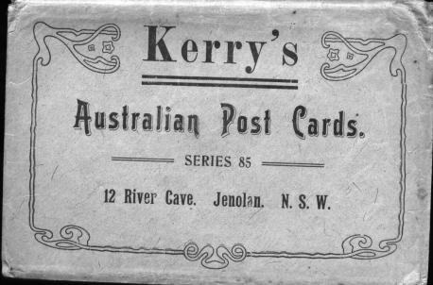

SUMMARY : Jenolan JK85 - cards to date

 |  | A | B | C | D
JK85.1 | Mops | * | * | * | *
JK85.2 | Punt | * |  | * | *
JK85.3 | Nymph’s Baths | * | * |  | *
JK85.4 | White Temple | * | * |  | *
JK85.5 | Grand Column | * | * | * | *
JK85.6 | Furze Bush | * |  | * | *
JK85.7 | Niagara | * |  | * | *
JK85.8 | Neptune’s Den | * |  | * | *
JK85.9 | White Gum Tree | * |  | * | *
JK85.10 | Esther | * |  | * | *
JK85.11 | Great Shawl | * |  | * | *
JK85.12 | Red Temple | * |  | * | *

Summarising the Printed Series

At this stage, before proceeding to deal with other forms of
card from Charles Kerry, it is perhaps useful to present an
overview of the printed series. The date shown here is the
earliest date of use which we have actually recorded.
However, all these series were included in Kerry's 1908
listing, and so were apparently available then.

Our Number | Kerry Number | Details | Approx. Date | No. Of Views
0 |  | Various Half-picture | 1901 | ?
00 |  | Various | 1903 | 16
01 | 1 | Various (“Old Caves”) | 1905 | 12
JK31 | 31B | Various (“New Caves”) | 1905 | 12
 | 76 | Lucas Cave | 1910 | 12
JK77 | 77 | Left Imperial (Chifley) | 1910 | 12
JK78 | 78 | Right Imperial (Imperial) | 1910 | 12
JK79 | 79 | Landscapes | 1910 | 12
JK80 | 80 | Jubilee Cave | ? | 6
JK81 | 81 | Nettle / Arch Caves | 1914? | 6
JK82 | 82 | Skeleton Cave (Cerberus) | 1910 | 6
JK83 | 83 | Orient Cave | 1910 | 12
JK84 | 84 | Temple of Baal | 1911 | 6
JK85 | 85 | River Cave | 1913? | 12

